How to Design a RAML-Based REST API With Mulesoft Anypoint API Manager:
• RAML is acronym of REST MODELLING API LANGUAGE.
• It is based on YAML Format and is used to design REST APIs.
• RAML is easily understood, Readable, Clear and understandable.
How to create a REST API using API manager:
• Create a new account in Mulesoft anypoint platform.
1) Create an API in API manager.
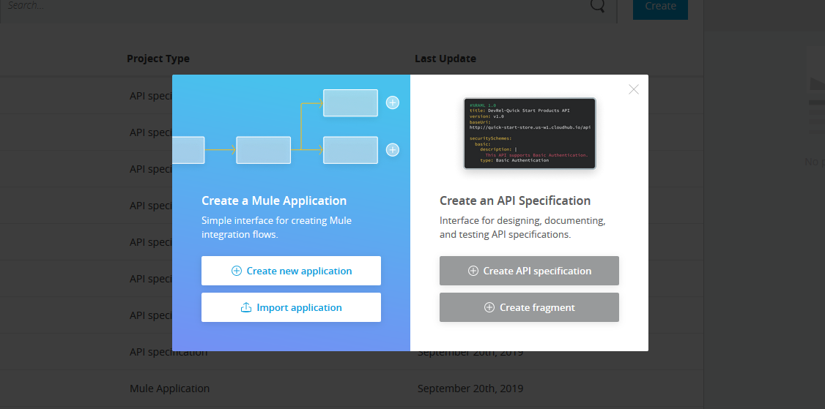
Create API Specification with name as shown above:
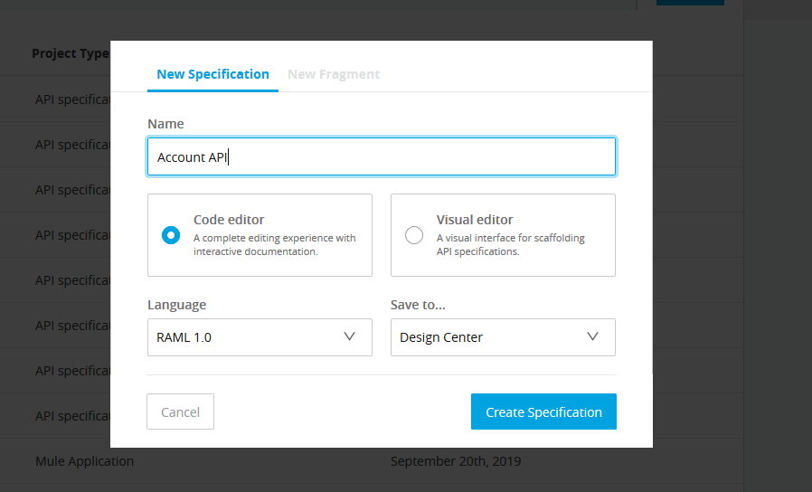
Then It navigates to API Manager Designer, we can write the RAML code there.

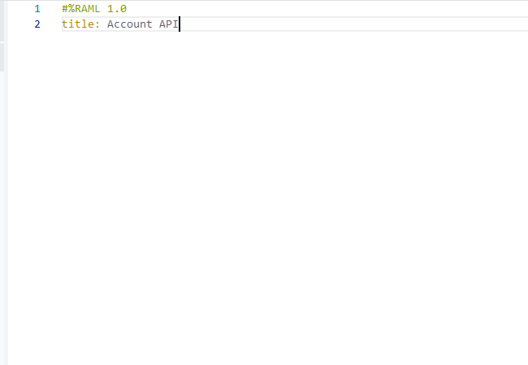

We can see title and version have already been defined by default at the root level. Now, we can start defining the RAML.
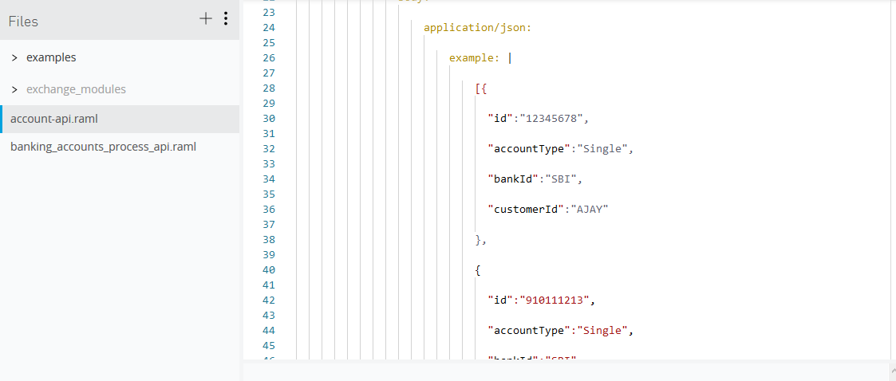
2)Test the API from API Manager:
Test the API by enabling mocking service. After enabling the mocking service, the base URL Will generated.
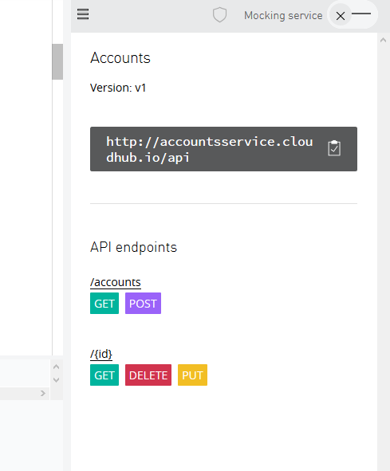

2)RAML example:
#%RAML 0.8
title: Accounts
version: v1
baseUri: http://accountsservice.cloudhub.io/api
/accounts:
description: Collection of Accounts
get:
description: Get list of all Accounts
responses:
"200":
description: Accounts found
body:
application/json:
example: |
[{
"id":"12345678",
"accountType":"Single",
"bankId":"SBI",
"customerId":"AJAY"
},
{
"id":"910111213",
"accountType":"Single",
"bankId":"SBI",
"customerId":"KUMAR"
}]
"404":
description: No Accounts found
body:
application/json:
example: |
{
"message":"No Accounts found"
}
post:
description: Add an Account
body:
application/json:
example: |
{
"id":"910111214",
"accountType":"Single",
"bankId":"SBI",
"customerId":"NANDU"
}
responses:
"201":
description: Account is successfully created
body:
application/json:
example: |
{
"id":"910111214",
"accountType":"Single",
"bankId":"SBI",
"customerId":"NANDU"
}
/{id}:
description: Particular Account
uriParameters:
id:
displayName: id
type: string
required: true
repeat: false
get:
description: Retrieve an account by id
responses:
"200":
description: Account by the specified account id exists.
body:
application/json:
example: |
{
"id":"12345678",
"accountType":"Single",
"bankId":"SBI",
"customerId":"AJAY"
}
"404":
description: Account by the specified account id does not exists.
body:
application/json:
example:
{
"message":"Account specified by the account id does not exists"
}
delete:
description: Delete an account by id
responses:
"204":
description: Successfully deleted the account specified by the id
body:
application/json:
example: |
{
"message":"Account specified by the id successfully deleted"
}
put:
description: Replace an account by id
body:
application/json:
example: |
{
"accountType":"Joint",
"bankId":"SBI",
"customerId":"AJAY"
}
responses:
"204":
description: Successfully replaced the account details for the account id
body:
application/json:
example: |
{
"message":"Account specified by the id successfully updated"
}

• Now The API is created using Anypoint studio.

